Electric Motor Temperature Prediction Using Machine Learning

Project Description:
Introduction:
The permanent-magnet synchronous machine (PMSM) drive is one of the best choices for a full range of motion control applications. For example, the PMSM is widely used in robotics, machine tools, actuators, and it is being considered in high-power applications such as industrial drives and vehicular propulsion. It is also used for residential/commercial applications. The PMSM is known for having low torque ripple, superior dynamic performance, high efficiency, and high-power density.
The task is to design a model with appropriate feature engineering that estimates the target temperature of a rotor.
In this project, we will be using algorithms such as Linear Regression, Decision Tree, Random Forest and SVM. We will train and test the data with these algorithms and select the best model. The best algorithm will be selected and saved in pkl format. We will be doing flask integration and IBM deployment.
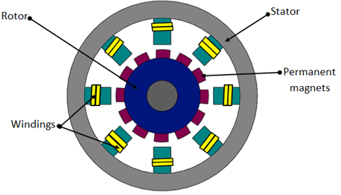

Technical Architecture:
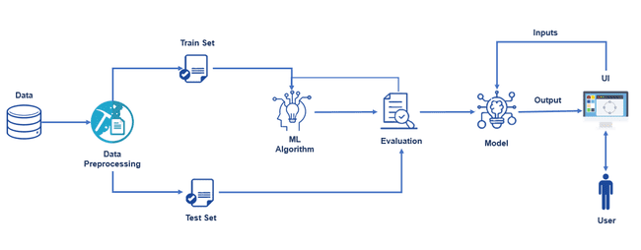
Pre requisites:
To complete this project, you must require following software’s concepts and packages
- Anaconda navigator:
  - Refer to the link below to download anaconda navigator

Link : https://www.youtube.com/watch?v=5mDYijMfSzs
- Python packages:
Open anaconda prompt as administrator.
  - Type “pip install numpy” and click enter.
  - Type “pip install pandas” and click enter.
  - Type “pip install matplotlib” and click enter.
  - Type “pip install scikit-learn” and click enter.
  - Type “pip install Flask” and click enter.
The above steps allow you to install the packages in the anaconda environment

Launch Jupyter
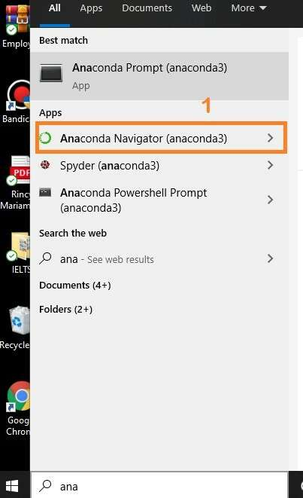
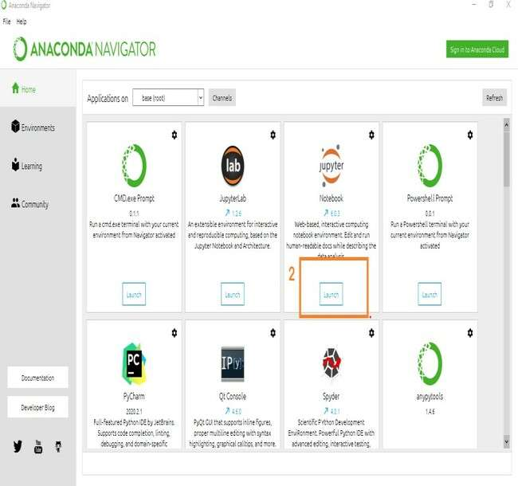
Search for Anaconda Navigator and open Launch Jupyter notebook.

  - Then you will be able to see that the jupyter notebook runs on localhost:5000.
  - To Create a new file Go to New 🡪Python3.The file in jupyter notebook is saved with
.ipynb extension.
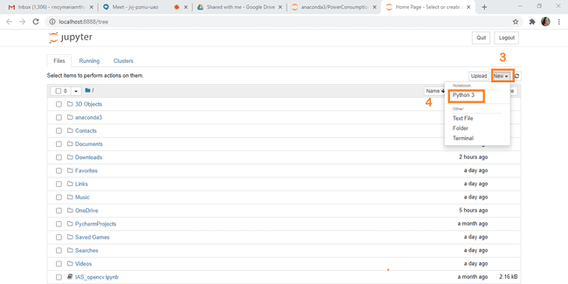

  - Flask Basics : https://www.youtube.com/watch?v=lj4I_CvBnt0

Project Objectives:
By the end of this project:
  - You’ll be able to understand the problem to classify if it is a regression or a classification kind
of problem.
  - You will be able to know how to pre-process / clean the data using different data preprocessing techniques.
  - You will be able to analyse or get insights of data through visualization.
  - Applying different algorithms according to dataset and based on visualization.
  - You will be able to know how to find the accuracy of the model.
  - You will be able to know how to build a web application using the Flask framework.

Project Flow:
  - User interacts with the UI (User Interface) to enter the input values
  - Entered input values are analyzed by the model which is integrated
  - Once model analyses the input the prediction is showcased on the UI To accomplish this, we have to complete all the activities and tasks listed below
  - Data Collection.
    - Collect the dataset or Create the dataset
  - Data Preprocessing.
    - Import the Libraries.
    - Importing the dataset.
    - Checking for Null Values.
    - Data Visualization.
    - Taking care of Missing Data.
    - Label Encoding.
    - OneHot Encoding.
    - Splitting Data into Train and Test.
    - Feature Scaling.
  - Model Building
    - Import the model building Libraries
    - Initializing the model
    - Training and testing the model
    - Evaluation of Model
    - Save the Model
  - Application Building
    - Create an HTML file
    - Build a Python Code

Project Structure:
Create a Project folder which contains files as shown below
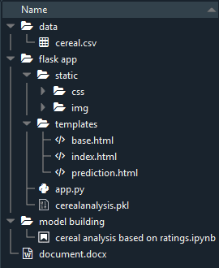
  - A python file called app.py for server side scripting.
  - We need the model which is saved and the saved model in this content is cerealanalysis.pkl
  - Templates folder which contains base.HTML file, index.HTML file, prediction.HTML file.
  - Static folder which contains css folder which contains style.css .

Milestone 1: Data Collection:
ML depends heavily on data, without data, it is impossible for an “AI” to learn. It is the most crucial aspect that makes algorithm training possible. In Machine Learning projects, we need a training data set. It is the actual data set used to train the model for performing various actions.

Activity1: Download the dataset
You can collect datasets from different open sources like kaggle.com, data.gov, UCI machine learning repository etc.
The dataset used for this project was obtained from Kaggle . Please refer to the link given below to download the data set and to know about the dataset
https://www.kaggle.com/crawford/80-cereals

Milestone 2: Data Preprocessing
Data Pre-processing includes the following main tasks
- Import the Libraries.
- Importing the dataset.
- Checking for Null Values.
- Data Visualization.
- Label Encoding.
- OneHot Encoding.
- Splitting Data into Train and Test.

Activity 1: Import The Libraries
- It is important to import all the necessary libraries such as pandas, numpy, matplotlib.
- Numpy- It is an open-source numerical Python library. It contains a multi-dimensional array and matrix data structures. It can be used to perform mathematical operations on arrays such as trigonometric, statistical, and algebraic routines.
- Pandas- It is a fast, powerful, flexible and easy to use open source data analysis and manipulation tool, built on top of the Python programming language.
- Seaborn- Seaborn is a Python data visualization library based on matplotlib. It provides a high-level interface for drawing attractive and informative statistical graphics.
- Matplotlib- Visualisation with python. It is a comprehensive library for creating static,animated, and interactive visualizations in Python
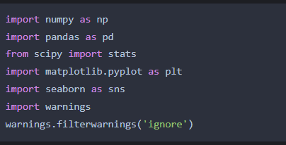

Activity 2: Read the Datasets

  - You might have your data in .csv files, .excel files

  - Let’s load a .csv data file into pandas using read_csv() function.We will need to locate the directory of the CSV file at first (it’s more efficient to keep the dataset in the same directory as your program).

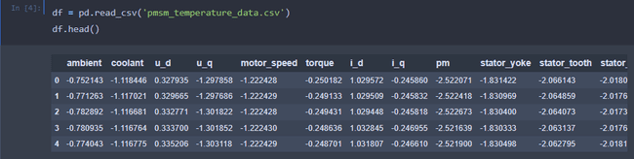

  - If your dataset is in some other location ,Then
Data=pd.read_csv(r”File_location”)
Note:r stands for "raw" and will cause backslashes in the string to be interpreted as actual backslashes rather than special characters.

  - If the dataset is in the same directory of your program, you can directly read it, without giving raw as r.

  - Our Dataset pmsm_temperature contains following Columns
- ambient
- coolant
- U_d
- U_q
- Motor_speed
- torque
- I_d
- I_q
- pm
- Stator_yoke
- Stator_tooth
- stator
The output column to be predicted is rating .Based on the input variables we predict the temperature

Activity 3: Analyse the data
  - head() method is used to return top n (5 by default) rows of a DataFrame or series.

  - describe() method computes a summary of statistics like count, mean, standard deviation, min, max and quartile values.
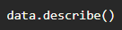
The output is as shown below

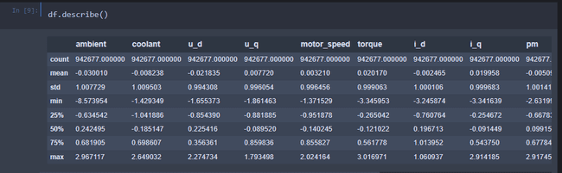
info() gives information about the data
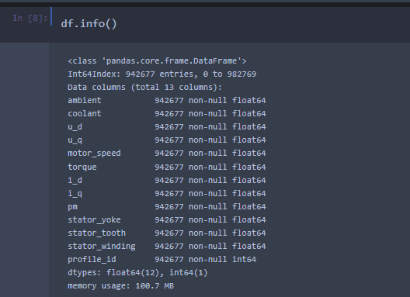

Activity 4: Handling Missing Values

- After loading it is important to check the complete information of data as it can indication many of the hidden information such as null values in a column or a row
- Check whether any null values are there or not. if it is present then following can be done,
- a. Imputing data using Imputation method in sklearn
b. Filling NaN values with mean, median and mode using fillna() method.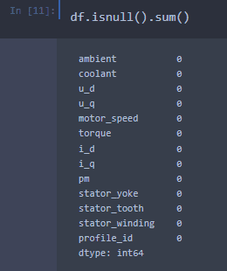

- Heatmap:Ity of representing the data in 2-D form.It gives coloured visual summary of the data

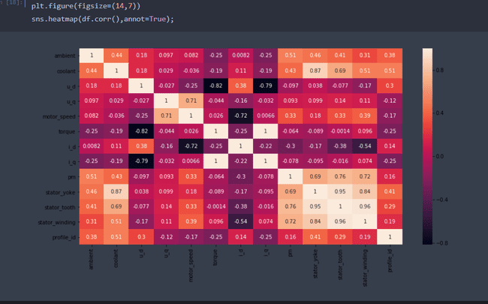
From the heatmap, we see that there are no missing values in the dataset

Activity 5: Data Visualisation
  - Data visualization is where a given data set is presented in a graphical format. It helps the detection of patterns, trends and correlations that might go undetected in text-based data.
  - Understanding your data and the relationship present within it is just as important as any algorithm used to train your machine learning model. In fact, even the most sophisticated machine learning models will perform poorly on data that wasn’t visualized and understood properly.
  - To visualize the dataset we need libraries called Matplotlib and Seaborn.
  - The Matplotlib library is a Python 2D plotting library which allows you to generate plots, scatter plots, histograms, bar charts etc.
Let’s visualize our data using Matplotlib and seaborn library.

Before diving into the code, let's look at some of the basic properties we will be using when plotting.
xlabel: Set the label for the x-axis.
ylabel: Set the label for the y-axis.

Visualizing And Analyzing The Data
As the dataset is downloaded. Let us read and understand the data properly with the help of some visualization techniques and some analyzing techniques.
Note: There is n number of techniques for understanding the data. But here we have used some of it. In an additional way, you can use multiple techniques.
title: Set a title for the axes.
Legend: Place a legend on the axes.

- data.corr() gives the correlation between the columns

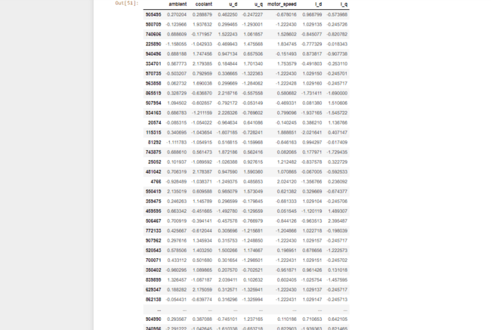
- Box plot
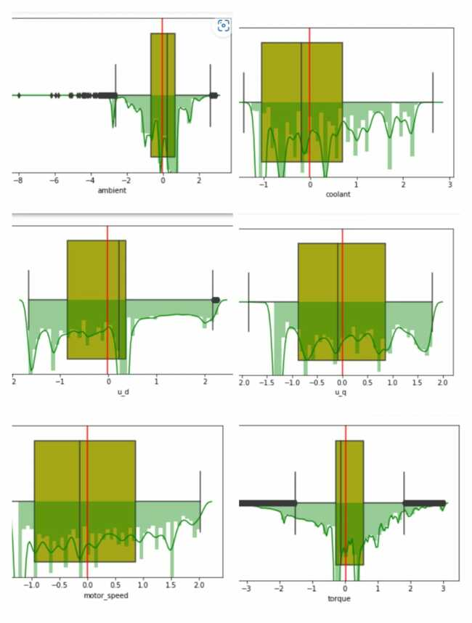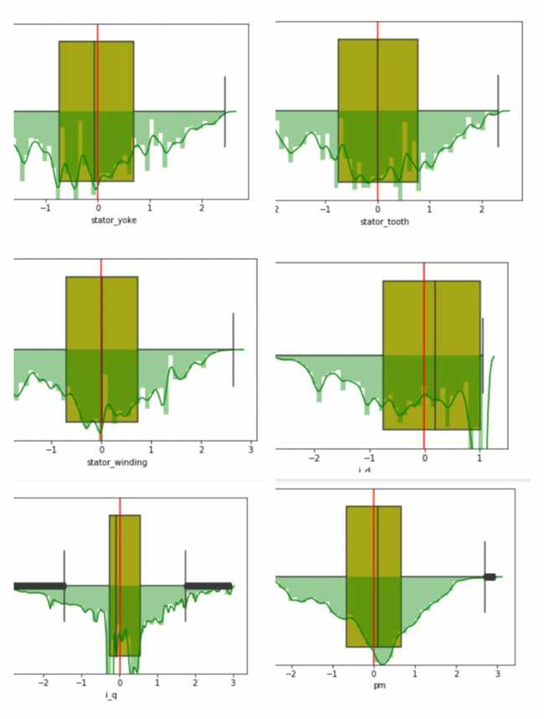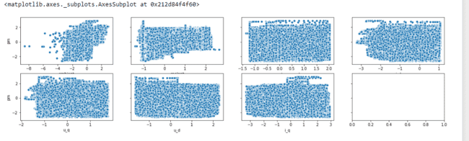

Activity 6: Label Encoding
In machine learning, we usually deal with datasets which contain multiple labels in one or more than one column. These labels can be in the form of words or numbers. To make the data understandable or in human readable form, the training data is often labelled in words.
Label Encoding refers to converting the labels into numeric form so as to convert it into the machine- readable form. Machine learning algorithms can then decide in a better way on how those labels must be operated. It is an important preprocessing step for the structured dataset in supervised learning.

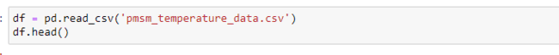Data after label encoding
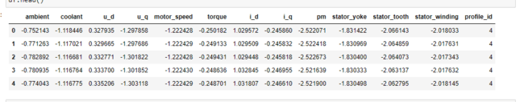

All the data is converted into numerical values.

Activity 7: Splitting the Dataset into Dependent and Independent variable

  - In machine learning, the concept of dependent variable (y) and independent variables(x) is important to understand. Here, Dependent variable is nothing but output in the dataset and the independent variable is all inputs in the dataset.
  - With this in mind, we need to split our dataset into the matrix of independent variables and the vector or dependent variable. Mathematically, Vector is defined as a matrix that has just one column.
To read the columns, we will use iloc of pandas (used to fix the indexes for selection) which takes two parameters — [row selection, column selection].
Let’s split our dataset into independent and dependent variables.

  - The independent variable in the dataset would be considered as 'x' and name, mfr, type, calories , protein , fat, sodium , fiber, carbo, sugars , potass , vitamins , shelf , weight , cups columns would be considered as independent variables.
  - The dependent variable in the dataset would be considered as 'y' and the ' rating ' column is considered as dependent variable.

Now we will split the data of independent variables,
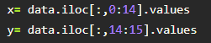

From the above code “:” indicates that you are considering all the rows in the dataset and “0:18” indicates that you are considering columns 0 to 8 such as sex, job and purpose as input values and assigning them to variable x. In the same way in the second line “:” indicates you are considering all the rows and “18:19” indicates that you are considering only the last column as output value and assigning them to variable y.
After splitting we see the data as below x
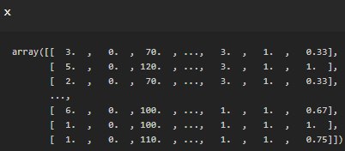

Y
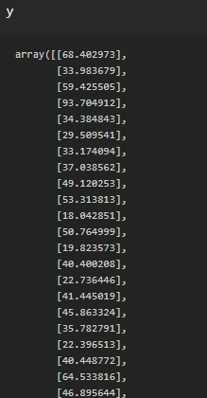

Activity 8: OneHot Encoding
Sometimes in datasets, we encounter columns that contain numbers of no specific order of preference. The data in the column usually denotes a category or value of the category and also when the data in the column is label encoded. This confuses the machine learning model, to avoid this, the data in the column should be One Hot encoded.

One Hot Encoding –
It refers to splitting the column which contains numerical categorical data to many columns depending on the number of categories present in that column. Each column contains “0” or “1” corresponding to which column it has been placed.
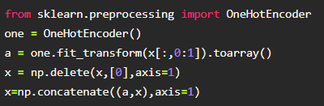

Activity 9: Splitting the data into Train and Test
  - When you are working on a model and you want to train it, you obviously have a dataset. But after training, we have to test the model on some test dataset. For this, you will have a dataset which is different from the training set you used earlier. But it might not always be possible to have so much data during the development phase. In such cases, the solution is to split the dataset into two sets, one for training and the other for testing.
  - But the question is, how do you split the data? You can’t possibly manually split the dataset into two sets. And you also have to make sure you split the data in a random manner. To help us with this task, the Scikit library provides a tool, called the Model Selection library. There is a class in the library which is,‘train_test_split.’ Using this we can easily split the dataset into the training and the testing datasets in various proportions.
  - The train-test split is a technique for evaluating the performance of a machine learning algorithm.
  - Train Dataset: Used to fit the machine learning model.
  - Test Dataset: Used to evaluate the fit machine learning model.
  - In general you can allocate 80% of the dataset to training set and the remaining 20% to test set.We will create 4 sets— X_train (training part of the matrix of features), X_test (test part of the matrix of features), Y_train (training part of the dependent variables associated with the X train sets, and therefore also the same indices), Y_test (test part of the dependent variables associated with the X test sets, and therefore also the same indices.
  - There are a few other parameters that we need to understand before we use the class:
  - test_size — this parameter decides the size of the data that has to be split as the test dataset. This is given as a fraction. For example, if you pass 0.5 as the value, the dataset will be split 50% as the test dataset
  - train_size — you have to specify this parameter only if you’re not specifying the test_size. This is the same as test_size, but instead you tell the class what percent of the dataset you want to split as the training set.
  - random_state — here you pass an integer, which will act as the seed for the random number generator during the split. Or, you can also pass an instance of the Random_state class, which will become the number generator. If you don’t pass anything, the Random_state instance used by np.random will be used instead.
  - Now split our dataset into a train set and test using train_test_split class from scikit learn library.

Milestone 3: Model Building:
Model building includes the following main tasks
    - Import the model building Libraries
    - Initializing the model
    - Training and testing the model
    - Evaluation of Model
    - Save the Model

Activity 1: Training and Testing the Model
  - Once after splitting the data into train and test, the data should be fed to an algorithm to build a model.
  - There are several Machine learning algorithms to be used depending on the data you are going to process such as images, sound, text, and numerical values. The algorithms that you can choose according to the objective that you might have may be Classification algorithms or Regression algorithms.
1.Linear Regression 2.Decision Tree Regressor 3.Random Forest Regressor
We’re going to use x_train and y_train obtained above in train_test_split section to train our decision
tree regression model. We’re using the fit method and passing the parameters as shown below.

We are using the algorithm from Scikit learn library to build the model as shown below,

Support Vector Machine Model
A function named SVR is created and train and test data are passed as the parameters. Inside the function, SVR algorithm is initialized and training data is passed to the model with .fit() function. Test data is predicted with .predict() function and saved in new variable. For evaluating the performance of the model, we use root mean square error and r-square value.
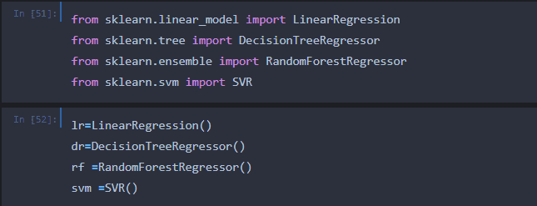

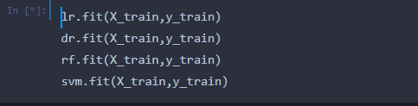

Activity 2: Model Evaluation
After training the model, the model should be tested by using the test data which has been separated while splitting the data for checking the functionality of the model.

Regression Evaluation Metrics:
These model evaluation techniques are used to find out the accuracy of models built in regression type of machine learning models. We have three types of evaluation methods.

- R – Square (𝑅²)
Formula for calculating (𝑅²) is given by:

𝑅2 = 𝑇𝑆𝑆 − 𝑅𝑆𝑆
𝑇𝑆𝑆

- Total Sum of Squares (TSS) : TSS is a measure of total variance in the response/ dependent variable Y and can be thought of as the amount of variability inherent in the response before the regression is performed.
- Residual Sum of Squares (RSS) : RSS measures the amount of variability that is left unexplained after performing the regression.
- (TSS – RSS) measures the amount of variability in the response that is explained (or removed) by performing the regression
Where N is the number of observations used to fit the model, σx is the standard deviation of x, and σy is the standard deviation of y.

  - 𝑅² ranges from 0 to 1.
  - 𝑅² of 0 means that the dependent variable cannot be predicted from the independent variable
  - 𝑅² of 1 means the dependent variable can be predicted without error from the independent variable
  - An 𝑅² between 0 and 1 indicates the extent to which the dependent variable is predictable. An 𝑅² of 0.20 means that 20 percent of the variance in Y is predictable from X; an 𝑅² of 0.40 means that 40 percent is predictable; and so on.

Root Mean Square Error (RMSE)

RMSE tells the measure of dispersion of predicted values from actual values. The formula for calculating RMSE is

𝑅² = {(1 ) * ∑ (x
− 𝑚𝑒𝑎𝑛(𝑥)) ∗ (𝑦 − 𝑚𝑒𝑎𝑛(𝑦))]/(𝜎 ∗ 𝜎

)}²
^{N}

I x y
^{N:Total number of observation}

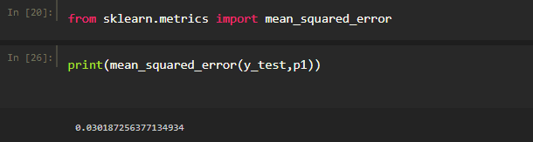
N : Total number of observations

Though RMSE is a good measure for errors, the issue with it is that it is susceptible to the range of your dependent variable. If your dependent variable has a thin range, your RMSE will be low and if the dependent variable has a wide range RMSE will be high. Hence, RMSE is a good metric to compare between different iterations of a model.

Mean Absolute Percentage Error (MAPE)

To overcome the limitations of RMSE, analysts prefer MAPE over RMSE which gives error in terms of percentages and hence comparable across models. Formula for calculating MAPE can be written as:

𝑅𝑀𝑆𝐸 = √∑ (𝑌𝐴𝑐𝑡𝑢𝑎𝑙− 𝑌𝑃𝑟𝑒𝑑𝑖𝑐𝑡𝑒𝑑)2
𝑁

N : Total number of observations

For testing the model we use the below method,
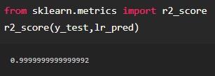

Activity 3: Save the Model
After building the model we have to save the model.

Pickle in Python is primarily used in serializing and deserializing a Python object structure. In other words, it's the process of converting a Python object into a byte stream to store it .

file/database, maintain program state across sessions, or transport data over the network. wb indicates write method and rd indicates read method.

This is done by the below code
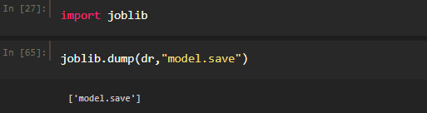

Milestone 4 : Application Building

In this section, we will be building a web application that is integrated to the model we built. A UI is provided for the uses where he has to enter the values for predictions. The enter values are given to the saved model and prediction is showcased on the UI.

This section has the following tasks

  - Building HTML Pages
  - Building server side script

Activity 1: Build HTML Code
    - In this HTML page, we will create the front end part of the web page. In this page we will accept input from the user and Predict the values.
For more information regarding HTML
https://www.w3schools.com/html/
In our project we have 3 HTML files ,they are
  - base.html
  - index.html
  - prediction.html

base.html

Build An HTML Page
We Build an HTML page to take the values from the user in a form and upon clicking on the predict button we get the temperature predicted. The values predicted are normalized values according to the dataset. Hence units are not considered. You can get these files from the project folder.

Building Html Pages:
For this project, create three HTML files namely
? Manual_predict.html
? Sensor_predict.html
and save them in the templates folder.
For more information regarding HTML: Link

Let’s see how our home.html page looks like
The html page looks

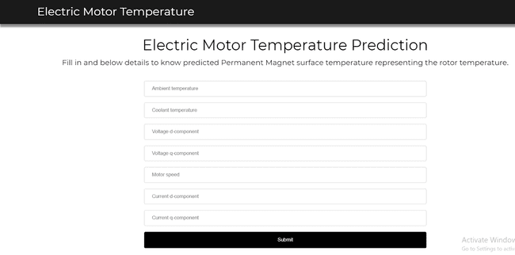

Activity 2: Main Python Script
Let us build an app.py flask file which is a web framework written in python for server-side scripting.
Let’s see the step by step procedure for building the backend application.
In order to develop web api with respect to our model, we basically use the Flask framework which is written in python.

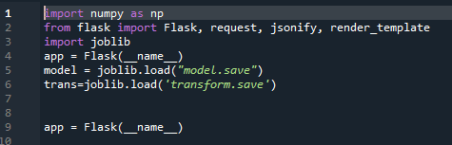
Load the home page
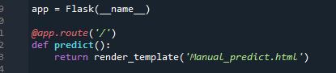
Prediction function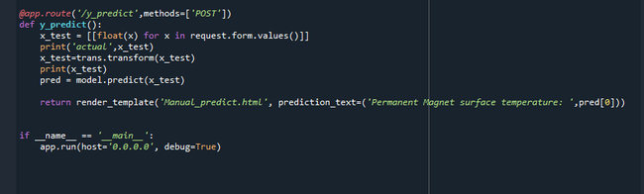

Activity 3: Run the App
    - Open anaconda prompt from the start menu
    - Navigate to the folder where your python script is.
    - Now type “python app.py” command
    - Navigate to the localhost where you can view your web page

Then it will run on localhost:5000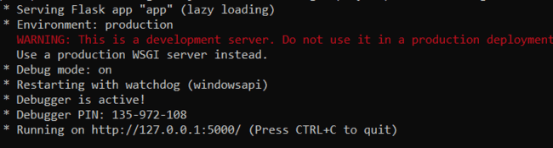

Output screen

